`Dear Diary,

Yesterday was great. It was such a reflective day for me. I started off pretty sad and upset still by what had happened at Otto’s house the night before. But I talked through some of it with Margarita and she made me feel better about it. I was going to just do homework, but then I said fuck it and decided to just have a day to myself.

I was supposed to hang out with Elvis in the afternoon, Claudia and Sierra in the evening, John Chapman at night, and then even John Detlefs after that, but I cancelled on all of them. I brought my little pen with me and walked around SLO. I walked several miles downtown and ended up at the creek. I stayed there for probably almost an hour, just listening to music and looking at the people around me. It was so nice out, the sun made the winter day feel warmer.

I walked back home and got some Boba on the way. Then I decided to call Maxwell, because even though it was my day, he always tends to give good perspective and it’s good for me. We talked for a little while and then I went back to the apartment, just in time to leave again.

I drove myself to pirates cove and made it just before sunset. I found a nice big boulder that no one was near and sat down on it. I got a little bit more high. It was so nice. I wasn’t listening to music or people, I was listening to the sound of the crashing waves… the sunset was so perfect.

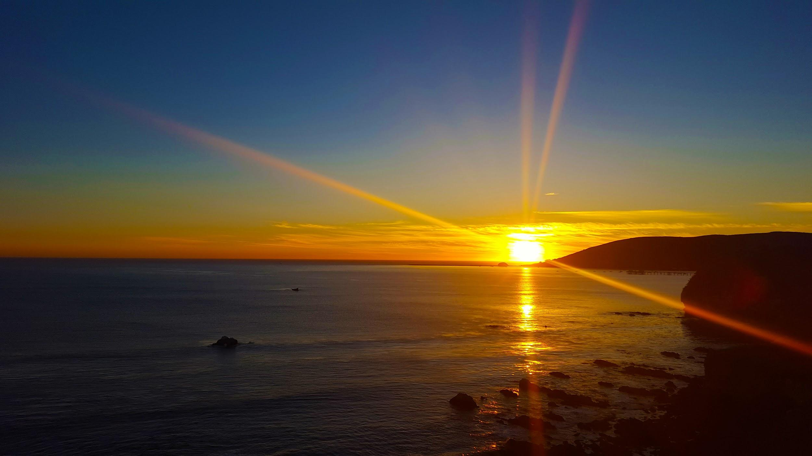

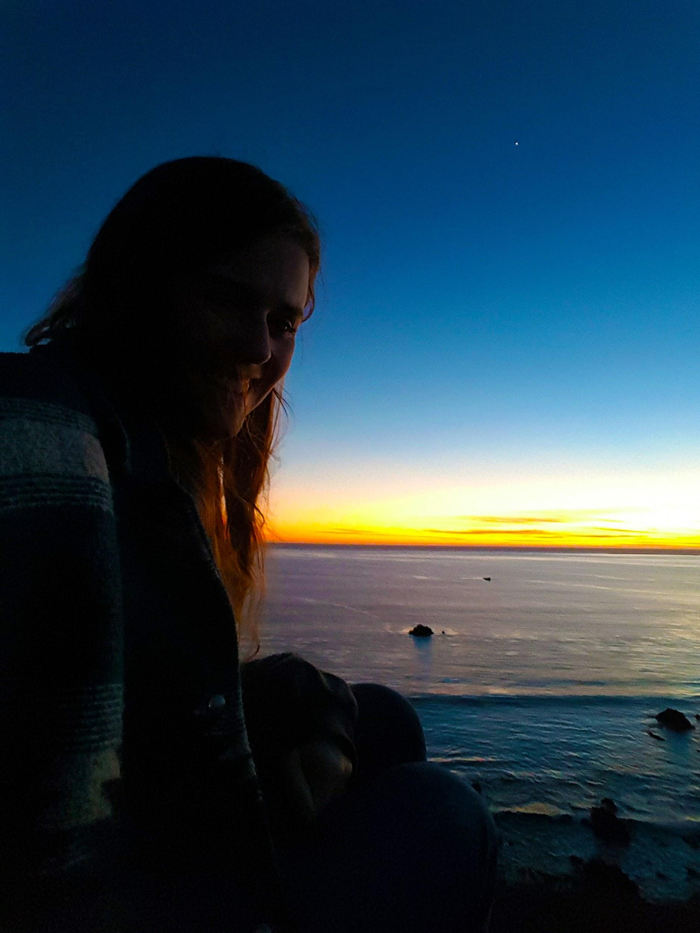

I just decided to add some photos that I took because I didn’t want to forget how great it was. To be able to just have a day to myself to do the things that I wanted and to reflect on the things that I needed to is so great.

I went to get food at Panda Express afterwards, then I got home and ate and watched some Planet Earth. Margarita and Trevor went downtown so I just got to enjoy being home alone in the apartment. I walked to 711 and got some ice cream too.

Some things that I reflected on:

I don’t think I like John that much anymore (Detlefs). This is because yesterday he was drunk and was snapchatting me and texting me and calling me non-stop and it made me really realize how excessive it was on a day like yesterday where I just wanted to be able to do my own thing and he was trying to prevent me from that.

I think I am becoming a very independent woman. I love that I am able to do so many things on my own now and that I can enjoy them fully and be happy about what I’m doing. It says a lot about who I am. I am excited to keep growing up and getting to spend time with myself and learning who I am.

I think days like yesterday are what help me learn what my personality is and what my true thoughts and feelings about things are. There are so many days that I’ve spent with people I may not have necessarily wanted to or doing something that I may not have necessarily wanted to do. I usually find the good in things so I adapt to others needs and wants instead of figuring out what my own are.

I think I’m finally realizing a lot of things about myself and the person that I want to be. It’s so good to know these things. I want to be someone that is nice to everyone. I don’t ever want to judge someone for something that they do, unless it’s incredibly detrimental to them or to someone else. I want to be able to be there for many, but I can’t forget to be there for myself when I need it too. I am the most important person in my life, and I need to make sure that I don’t forget that as often as I have in the past.

I want to make a meaningful and purposeful impact on everyone that I cross paths with. I think that is what drives me to do good and to try to be positive whenever I can. I don’t see the point in being negative when I can just learn, grow, and find the positive in something. Everything is at least a learning experience (isn’t everything in life?) whether it is good or bad, so I just need to interpret it in a different way if it seems bad to me.

I’m not high right now, it’s 12pm on a Sunday and I have homework and have to go to actual work later so I think it’ll be a nice cleanse from yesterday. I have been smoking a lot though. Since I got that pen that makes it so easy and subtle I’ve been getting high at least once a day, if not twice a day. But I haven’t told anyone. I’ve been getting high when I get home from school so that it’ll be mostly worn off (but not all the way) by the time practice rolls around at night. Then I’ll usually get high again when I get home. I think that this kind of lifestyle won’t be sustainable once the quarter gets harder so I probably shouldn’t keep it up too much longer or else I could get dependent on it. I also feel like I am a pretty productive high person, so at least I’m not wasting my time. It definitely helps with hard and stressful times when I have to deal with it all by myself.

I know that I have support systems, but I love knowing that I am strong enough to deal with things on my own. I love learning how to be strong.

I’m getting stronger every day. Mentally, physically, and emotionally. I think that 2017 is going to be an amazing year in many ways. I have a feeling it will be a big year (as are most of the years in my life right now), but I think that I am really preparing myself for it.

I am learning so many new ways to cope with pain, hurt, stress, and sadness. I am learning that loneliness doesn’t have to be a sad or bad feeling. I am embracing so many parts of myself and my life that I never have before. It’s such a learning experience, and I’m doing it all by myself. But I am so happy about this. There is so much more to my life now than there ever was before, and it only continues to expand.

I am feeling enlightened in this new year.

I’ll write again soon. I enjoy sharing my thoughts and reflecting on them.

Until next time,

Jessie J. Smith